## Department of Computer Engineering

## A SOFTWARE TESTING AND QUALITY ASSURANCE

## PROJECT REPORT ON

## **E-Commerce Website Automation Testing Using Selenium**

SUBMITTED TO THE DEPARTMENT OF COMPUTER ENGINEERING AISSMS IOIT

## BE Computer Engineering

## SUBMITTED BY



|  |  |
| --- | --- |
| **STUDENT NAME** | **ERP No:** |
| **Onasvee Banarse** | **09** |
| **Kaustubh Kabra** | **37** |
| **Akash Mete** | **50** |
| **Harsh Shah** | **65** |

## 2022 -2023

**Department of Computer Engineering CERTIFICATE**

This is to certify that the project report

## “E-Commerce Website Automation Testing Using Selenium”

Submitted by

|  |  |
| --- | --- |
| STUDENT NAME | ERP No: |
| Onasvee Banarse | 09 |
| Kaustubh Kabra | 37 |
| Akash Mete | 50 |
| Harsh Shah | 65 |

is a bonafide students at this institute and the work has been carried out by them under the supervision of **Prof. Prajwal Gaikwad** and it is approved for the partial fulfillment of the Department of Computer Engineering AISSMS IOIT.

(**Prof. Prajwal Gaikwad**) (**Dr. S.N.Zaware**)

Mini-Project Guide Head of Computer Department

Place: Pune Date:



# Abstract

Tests with the purpose of validating the product works are named clean tests, or positive tests. The drawbacks are that it can only validate that the software works for the specified test cases. A finite number of tests cannot validate that the software works for all situations. On the contrary, only one failed test is sufficient enough to show that the software does not work. Dirty tests, or negative tests, refers to the tests aiming at breaking the software, or showing that it does not work. A piece of software must have sufficient exception handling capabilities to survive a significant level of dirty tests.

Selenium is a portable framework for testing web applications. Selenium provides a playback tool for authoring functional tests without the need to learn a test scripting language. In order to create a small web-based application by selecting relevant system environment we need selenium web driver and IDE. In order to gain better understanding and familiarity about selenium , we will target three things: Java, Selenium Webdriver, Testing to learn testing with Selenium. we will Identify the bugs using Selenium Web-Driver and IDE and we will generate test reports by testing.The tests can then run against most modern websites. Here we will test it on the login pages like instagram ,twitter,

facebook etc. There are many types of testing that can be done with Selenium. You can do smoke testing, sanity, testing, UI testing, regression testing, and more.For most testing scenarios, Selenium Automation Testing is considered an ideal option. But, when it comes to unit testing, developers need a modern automated unit testing framework that can create automated unit test cases and quickly integrates with Selenium.

Contents

Abstract 3

1. Introduction 5

2. Problem Statement 6

3. Software and Hardware Requirement Specification 7

5. Theory 8

6. TEST PLAN 13

7. Output 15

8. Conclusion 19

9. References 20

# 1. Introduction

Software testing is a set of activities conducted for finding errors in software. It is a process used to measure the quality of the software. Manual testing and automation testing are the two ways of testing. Manual testing is also called as static testing. It is carried out by the tester. Automation testing is also called as dynamic testing. But the problem is it is very time consuming process and requires more effort. So, automation testing is used to solve these problems. Automated testing is divided into four types such as reliability testing, security testing, correctness testing, and performance testing. It automates the steps of manual testing using automation tools . Automated tests are fast to execute and they are repeatable in nature. There are various tools available in the market which are used to test the process and targeted specific test environment. The environment may be functional, performance or exceptional testing etc. Testing tool should be selected on the basis of its compatibility with checklist for that purpose pilot round of the corresponding tool should be done. Cost is also an important factor for selection of tool.

# 2. Problem Statement

Create a small web-based application by selecting relevant system environment platform and programming languages. Narrate concise Test Plan consisting features to be tested and bug taxonomy. Narrate scripts in order to perform regression tests. Identify the bugs using Selenium WebDriver and IDE and generate test reports encompassing exploratory testing.

In this Project we will focus on following questions:

* to provide a reliable and easy to use software tool that allows test creation and test taking capabilities.
* to provide a database that stores questions, which can be used to automatically generate tests based on specified criteria
* to provide a secure test taking application and powerful automated grading tool and non-automated grading capabilities

# 3. Software and Hardware Requirement Specification

Software Used:

* Python (version 3 or above)-

Python is a high-level, general-purpose programming language. Its design philosophy emphasizes code readability with the use of significant indentation. The sentiment analysis is performed using python language and packages.

* VScode or any IDE–

Visual Studio Code is a source-code editor made by Microsoft for Windows, Linux and macOS. Features include support for debugging, syntax highlighting, intelligent code completion, snippets, code refactoring, and embedded Git.

Hardware Used:

The detailed hardware used for the project are:

|  |  |
| --- | --- |
| **Item** | **Description** |
| System | Asus TUF A15 |
| Processor | AMD Ryzen 5 4600H |
| RAM | 8 GB |
| System Type | 64-bit operating system, x64-based processor |
| SSD | 512 GB Solid State Drive |
| HDD | 1 TB Hard Disk Drive |
| Graphics | NVIDIA 4 GB Graphic Card |
| Operating System | Windows 10 Operating System |

# **5. Theory**

**What is Selenium?**

Selenium is a free (open source) automated testing suite for web applications across different browsers and platforms. Selenium is a suite of software tools to automate Web Browsers. It is an Open-source suite of tools mainly used for Functional and Regression Test Automation. Selenium is a free (open source) automated testing suite for web applications across different browsers and platforms. It is quite similar to HP Quick Test Pro (QTP now UFT) only that Selenium focuses on automating web-based applications. Testing done using Selenium tool is usually referred to as Selenium Testing

● Selenium supports various Operating environments.

Microsoft Windows

Linux

Macintosh

● Selenium supports various Browsers.

Mozilla Firefox

IE

Google Chrome

Safari

Opera etc…

● Selenium supports various programming environments to write programs (Test scripts)

Java

C#

Python

Perl

Ruby

PHP

**History of the Selenium Project**

Selenium first came to life in 2004.

● In 2006, Selenium WebDriver was launched at Google.

● In 2008, the whole Selenium team decided to merge Selenium WebDriver with Selenium RC to form a more powerful tool called Selenium 2.0

Selenium 1

■ (Selenium IDE + Selenium RC + Selenium Grid)

○ Selenium 2

■ (Selenium IDE + Selenium RC + Selenium WebDriver + Selenium Grid)

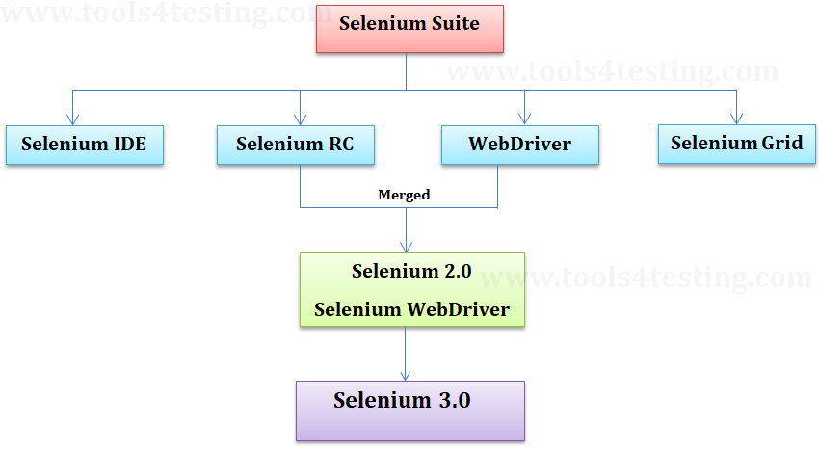

**Selenium’ Tools Suite**

Selenium is not just a single tool but a suite of software's, each catering to different testing needs of an organization. It has four components.

● Selenium Integrated Development Environment (IDE)

● Selenium Remote Control (RC)

● WebDriver

● Selenium Grid

**Selenium IDE Features :-**

Create Test Cases, Test suites (We can Record test cases or type Test steps

using element locators and Selenese commands)

* Edit Test Cases
* Execute Test cases, Test suites
* Debug Test Cases.
* Enhance Test Cases

**Drawbacks of Selenium IDE :-**

* It supports Mozilla Firefox browser only.
* It doesn’t support Programming logic/features to enhance Test cases.
* It doesn’t support Data-Driven Testing.
* It is not suitable for complex test case design.
* No centralized maintenance of Objects/Elements

**Selenium Remote Control (Selenium RC) :-**

Selenium RC was the flagship testing framework of the whole Selenium project for a long time. This is the first automated web testing tool that allowed users to use a programming language they prefer. As of version 2.25.0, RC can support the following programming languages:

* **J**ava
* C#
* PHP
* Python
* Perl
* Ruby

**Selenium WebDriver :-**

* It is a Programming interface to create and execute Test cases.
* Selenium IDE has IDE but doesn’t have Programming interface.
* Selenium WebDriver has Programming interface but doesn’t have IDE.
* It communicates directly to the browser.
* No need of Separate Server such as RC ServerUFT/QTP has both IDE as well as a Programming interface.
* Faster Execution than IDE & RC
* Selenium WebDriver supports various programming environments to write programs.
* Java
* C#
* Perl
* Python
* Ruby
* PHP
* Using Element/Object locators/properties and Webdriver Methods we can create and execute Test cases.
* Selenium Webdriver supports various browsers to create and execute a test case/test script/test

Note: Browser driver varies from one browser to another.

**Drawbacks of Selenium WebDriver**

* It doesn’t generate detailed Test Reports.
* No centralized maintenance of Object/elements
* It requires Programming Knowledge
* Cannot support the readily new browser
* Installation is More Complicated than Selenium IDE

No built-in mechanism for logging runtimemessage

**Selenium Grid :-**

* Selenium Grid is used to execute tests across multiple browsers, operating environments and machines in parallel.
* Selenium Grid 2 supports Selenium RC Tests as well as Selenium WebDriver Tests.
* Selenium WebDriver to create Test cases using Element locators and Webdriver methods.
* Java Programming to enhance test cases.
* TestNG Framework to group test cases, execute test batches and generate detailed test reports.

**Features:**

* Enables simultaneous running of tests in multiple browsers and environments.
* Saves time enormously.
* Utilizes the hub-and-node concept. The hub acts as a central source of Selenium
* commands to each node connected to it.

Memory usage is another important aspect of sorting algorithms, which in some cases can be more important than the execution time. Ideally, one wants to keep the value for this parameter small, but extra memory can often improve execution times, which leads to a time-space trade-off. One cannot have both, and therefore needs to find a reasonable compromise for what is best for the intended usage. For this reason, in-place sorting algorithms are often slower than its counterpart.

# 6. TEST PLAN

**Features to be tested:-**

* Open the given e-commerce website
* Select a product with quantity more than 1 and add to cart
* Select a product and update the delivery date and add to cart
* View cart and checkout as a guest
* Fill in all the delivery and checkout details
* Confirm order and check for the order confirmation message

**Test Environment:-**

• Environment

Windows 10

Chromedriver

Selenium

Python

Pycharm

VSCode

• Programming Languages

HTML

CSS

Python

• Testing tool used

Selenium

**Test Case Scenarios:-**

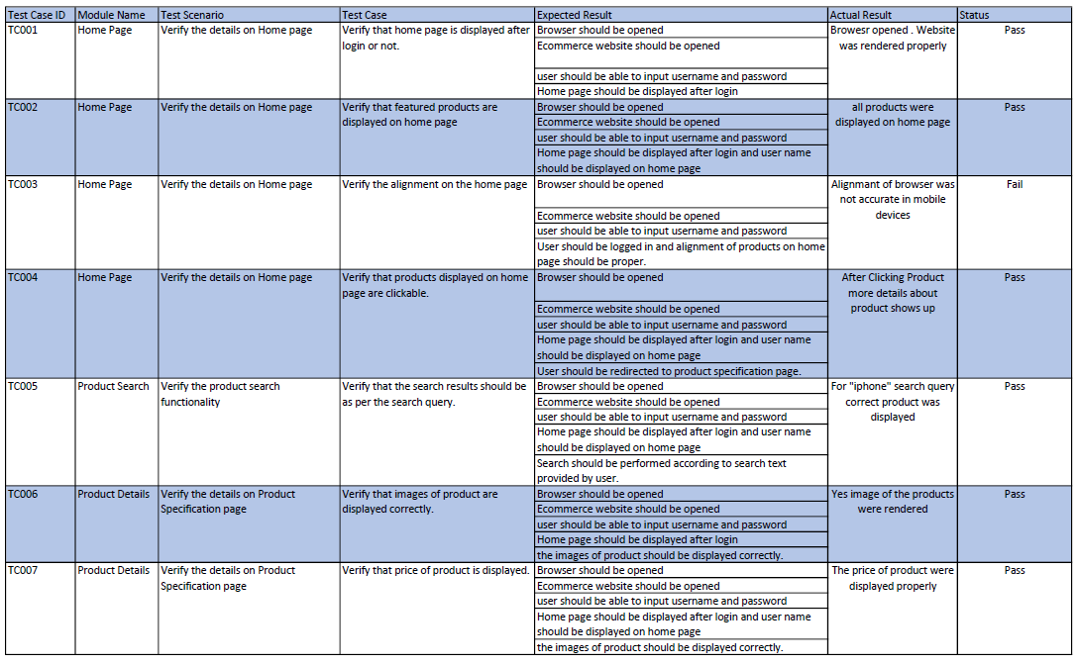

# **7. Output**

NoseTests Report:

# **8. Conclusion**

Test cases are important document for future prospective. Quality assurance team is the review of software products and related documentation for completeness, correctness, reliability and maintainability. It also includes assurance, that the system meets the specification and the requirements for its intended use and performance. In this research paper, I present an overview of our experience through a case study and also provide some new techniques. Today, most of the programmer/test engineers have face many problems regarding test case documentation.

In our project we studied concept of STLC and implemented on testing website.

# 9. References

1. Ramya, Paruchuri; Sindhura, Vemuri; Sagar, P. Vidya (2017). [IEEE 2017 Second International Conference on Electrical, Computer and Communication Technologies (ICECCT) - Coimbatore (2017.2.22-2017.2.24)] 2017 Second International Conference on Electrical, Computer and Communication Technologies (ICECCT) - Testing using selenium web driver. , (), 1–7. doi:10.1109/ICECCT.2017.8117878
2. Barab, S. & Squire, K. 2004. Design-based Research: Putting a Stake in the Ground. The Journal of the Learning Sciences, 13(1), 1 –14.
3. Dustin, E., Garrett, T. & Gauf, B. 2009. Books on Google Play Implementing Automated Software Testing: How to Save Time and Lower Costs While Raising Quality. New York City, New York, United States: Pearson Education Inc.
4. Itkonen, J., Mäntylä, M.V. & Lassenius, C. 2009. How do testers do it? An exploratory study on manual testing practices, in Proceedings of 3rd International Symposium on Empirical Software Engineering and Measurement.
5. Peffers, K., Tuunanen, T.A., Rothenberger, M. & Chatterjee, S. 2008. A Design Science Research Methodology for Information Systems Research. Journal of Management Information Systems. Abingdon: M.E. Sharpe, Inc.
6. Westby, E.J.H. 2015. Git for Teams: A User-Centered Approach to Creating Efficient Workflows in Git. Sebastopol: O’Reilly Media, Inc.
7. Selenium:

<https://www.selenium.dev/>

1. Selenium with Python Tutorial:

<https://www.javatpoint.com/selenium-python>